How to Write a Good Essay: Stop Summarizing, Start Commentating
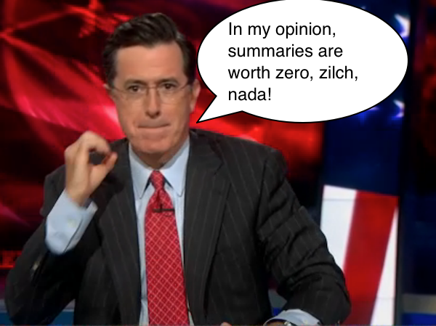
Chances are your professor has given you an assignment to write an essay that reflects on a piece of literature, or another body of work like a film or play. Do you know how to write a good essay? One basic way to elevate the quality of your next essay is to stop summarizing and start commentating.
And it’s easier than you may think.

How to Write a Good Essay Part 1: Learn the Difference between Commentary and Summary
You need to understand the difference between commentary and summary. While both writing styles can be used to discuss another piece of work (like a play, book, movie, or poem), this is about the sum total of their similarities.
Here are the three main differences between summary and commentary:
- Summary is a brief account giving the main points of something.
- Commentary is a series of explanations and interpretations.
- Summary is surface.
- Commentary is deep.
- Summary is regurgitation.
- Commentary is original.
There is only one way to provide a summary: You read or view a work, and then write down a recap of what the work is all about.
However, there are many ways to provide commentary, including:
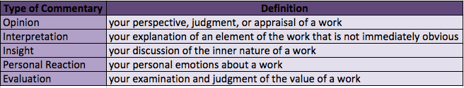
Here are some real life examples of summary and commentary:
A summary is something you’d read in a movie description or on the back of a book, like this summary of The Godfather: Part II from IMDb:
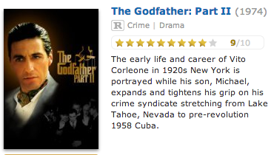
Commentary is what you’d read in a film or book review, like this one from Rotten Tomatoes:
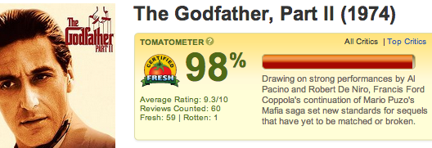
As you can see, the main difference between these two write-ups of The Godfather, Part II is the IMDb summary includes no opinion or evaluation, while the Rotten Tomatoes review includes the opinion “strong performances” and the evaluation “set(s) new standards for sequels that have yet to be matched or broken.”

How to Write a Good Essay Part 2: Sample Essay
So, now that you hopefully understand the difference between summary and commentary, let’s work on an example. I’m going to give both summary and commentary on a scene from my favorite movie of all time, Shaun of the Dead. This is probably the only movie on Earth that I’ve watched more than a dozen times.
I know you’re supposed to be writing an essay right now, so don’t procrastinate by watching this awesome, comedic zombie movie. But, as soon as you turn this essay in, if you haven’t seen it already, watch it! Seriously, it’s so good.
In the meantime, for our lesson, watch this YouTube clip of one of my favorite scenes from the film. It will serve as the body of work that I’m going to commentate on. [The clip can be found at https://www.youtube.com/watch?v=WUCqPxfpMCQ, but you can probably understand this without watching it.]
First, let me show you how I would write a summary of this scene:
In this scene from the 2004 movie Shaun of the Dead, Shaun (played by Simon Pegg) wakes up with a hangover and walks to the convenience store to buy a soda and an ice cream. In his hungover condition, he does not notice anything that is going on around him. On his way to the store, he walks by what appears to be zombies roaming the street. There is mayhem all around him. A car window is smashed and the alarm is blaring, a person is running for his life away from zombies, there are bloody handprints on the cooler, and the convenience store clerk is missing. On his way home, Shaun passes even more zombies, including one who he mistakes for a homeless person. When the zombie approaches him, Shaun says, “No, I don’t have any change. I didn’t even have enough for the shop.” He makes it home safely and turns on the TV, ignoring the news reports about the zombie invasion.
While this may be a perfectly good summary of this scene, it doesn’t offer any additional insight into the film. My summary simply regurgitates what happened, play-by-play. There’s really no point in reading this summary; instead, you could just watch the scene and learn everything I just discussed, and you’ll have more fun doing it.
When your professor asks you to provide thoughtful commentary on a piece of work, you can be sure that he or she does not want you to just give a detailed recap of the events. This does not show that you’ve put forth any effort. In fact, writing that summary took me under a minute, with little thought.
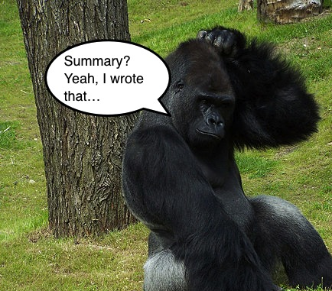
The one thing a summary can provide is background for your commentary. You want to give your reader some context on the piece of work, while also providing your insightful and opinionated commentary. Let’s start working on this now.

How to Write a Good Essay: Offer an Opinion
First, I’m going to insert an opinion into my summary. To make it easier for you to follow, I’ll highlight my opinion in green.
In this clever and satirical scene from the 2004 movie Shaun of the Dead, Shaun (played by Simon Pegg) wakes up with a hangover and walks to the convenience store to buy a soda and an ice cream.

How to Write a Good Essay: Offer an Interpretation
Next, I’ll insert an interpretation.
In his hungover condition, he does not notice anything that is going on around him. This provides insight on how Shaun, like many of us, lives his day-to-day life, almost as a zombie himself, just going through the motions without noticing the world in which he lives.

How to Write a Good Essay: Offer some Insight
Next, I’ll insert some insight.
On his way to the store, he walks by what appears to be zombies roaming the street. There is mayhem all around him, but this mayhem isn’t a far cry from Shaun’s daily reality. A car window is smashed and the alarm is blaring. Today it is from a zombie, but on a normal day, a regular thief could have smashed it. A person is running for his life away from zombies, but on a normal day, it could be a person running to catch the bus.

How to Write a Good Essay: Offer Your Personal Reaction
Next, I’ll insert my personal reaction:
There are bloody handprints on the cooler, and the convenience store clerk is missing, which, along with the creepy music soundtrack, gives a sense of impending doom as the viewer watches Shaun obliviously bumble along.
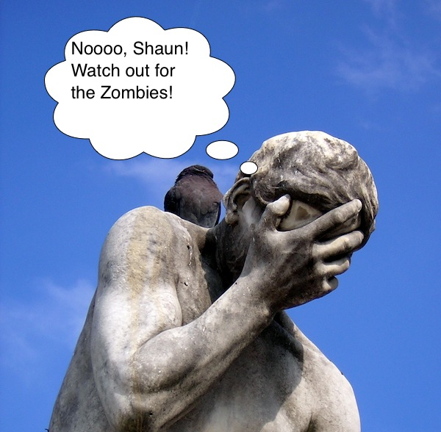

How to Write a Good Essay: Offer an Evaluation
Finally, I’ll insert my evaluation and a little more opinion and insight.
On his way home, Shaun passes even more zombies, including one who he mistakes for a homeless person. When the zombie approaches him, Shaun says, “No, I don’t have any change. I didn’t even have enough for the shop.” Incidents like these make this film the perfect satirical comedy about what it means to be alive in the 21st century. This is emphasized again when Shaun makes it home safely and turns on the TV, ignoring the news reports about the zombies. Thisbrilliant satire points to the sad fact that a typical person’s life is already so horrible that a zombie apocalypse wouldn’t even mark a change for the worse.

So, how does my final Shaun of the Dead commentary look as a whole? Check it out:
In this clever and satirical scene from the 2004 movie Shaun of the Dead, Shaun (played by Simon Pegg) wakes up with a hangover and walks to the convenience store to buy a soda and an ice cream.
In his hungover condition, he does not notice anything that is going on around him. This provides insight on how Shaun, like many of us, lives his day-to-day life, almost as a zombie himself, just going through the motions without noticing the world in which he lives.
On his way to the store, he walks by what appears to be zombies roaming the street. There is mayhem all around him, but this mayhem isn’t a far cry from Shaun’s daily reality. A car window is smashed and the alarm is blaring. Today it is from a zombie, but on a normal day, a regular thief could have smashed it. A person is running for his life away from zombies, but on a normal day, it could be a person running to catch the bus.
There are bloody handprints on the cooler, and the convenience store clerk is missing, which, along with the creepy music soundtrack, gives a sense of impending doom as the viewer watches Shaun obliviously bumble along.
On his way home, Shaun passes even more zombies, including one who he mistakes for a homeless person. When the zombie approaches him, Shaun says, “No, I don’t have any change. I didn’t even have enough for the shop.” Incidents like these make this film the perfect satirical comedy about what it means to be alive in the 21st century. This is emphasized again when Shaun makes it home safely and turns on the TV, ignoring the news reports about the zombies. This brilliant satire points to the sad fact that a typical person’s life is already so horrible that a zombie apocalypse wouldn’t even mark a change for the worse.

How to Write a Good Essay Part 3: Final Rules to Consider
Now that you’ve seen commentary in action, I want to point out a couple more important rules that will help you write a good essay.

Rule One: Avoid Subjective Phrases
Even when giving commentary in the form of an opinion, avoid using subjective phrases like “I hope,” “I believe,” and “I think.” These are just throwaway phrases. As I discussed in my previous post about writing a cover letter, these phrases are redundant (you wrote the essay, so it’s obvious you think, believe, or hope what is written) and they reduce your credibility.

Rule Two: Maintain a 2:1 Ratio of Commentary to Summary
In general, you should provide approximately two points of commentary for every specific detail you offer. While summary is still important for giving your reader context, commentary is critical to writing a good essay.

Rule Three: Follow Your Instructor’s Rules
Sometimes your instructor will want you to only offer opinion; other times, he’ll want you to only offer insight or interpretation. Other times, you’ll have more freedom as to what type of commentary you include in your essay. The important thing to remember is to follow your instructor’s rules for the assignment.

